**Practical 1 Date: 11/07/2023**

**Aim**: Know your devices.

**Theory:**

* **Cables: -**

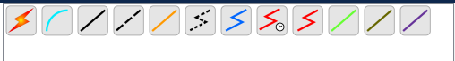

* **Straight Cable:**

A straight through cable is a type of twisted pair cable that is used in local area networks to connect a computer to a network hub such as a router. This type of cable is also sometimes called a patch cable and is an alternative to wireless connections where one or more computers access a router through a wireless signal.

* **Crossover Cable:**

The wire at pin 1 on one end of the cable connects to pin 3 at the other end of the cable. The wire at pin 2 connects to pin 6 on the other end of the cable. Remaining wires connect in the same positions at both ends.

* **Coaxial Cable:**

A coaxial cable is an electrical cable with a copper conductor and an insulator shielding around it and a braided metal mesh that prevents signal interference and cross talk. Coaxial cable is also known as coax.

* **Data Terminal Equipment (DTE):**

It is a device that is an information source or an information sink. It produces data and transfers them to a DCE, with essential control characters. Examples of DTE include computers, printers, and routers, etc.

* **Data Circuit Terminating Equipment (DCE):**

It is a device used as an interface between a DTE. It converts signals to a format appropriate to transmission medium and introduces it onto network line. Examples of DCE include modem, ISDN adaptors, satellites, and network interface cards, etc.

* **Router:**

A router is a device like a switch that routes data packets based on their IP addresses. The router is mainly a Network Layer device. Routers normally connect LANs and WANs and have a dynamically updating routing table based on which they make decisions on routing the data packets. The router divides the broadcast domains of hosts connected through it.

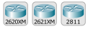

* **Switch:**

A switch is a multiport bridge with a buffer and a design that can boost its efficiency (many ports imply less traffic) and performance. A switch is a data link layer device. The switch can perform error checking before forwarding data, which makes it particularly effective because it only forwards good packets to the right port and does not transmit packets with problems.

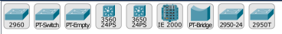

* The Cisco® Catalyst® 2960 Series is a family of fixed- configuration, standalone switches that provide Fast Ethernet and Gigabit Ethernet connectivity and support enhanced switching services, advanced security, IP communications, wireless networking, and scalable management.
* The Cisco Catalyst 2950 Series is a line of fixed-configuration, stackable, and standalone switches that provide wire-speed Fast Ethernet and Gigabit Ethernet connectivity.
* The Cisco® Catalyst® 3560 Series is a line of fixed-configuration, enterprise-class switches that include IEEE 802.3af and Cisco prestandard Power over Ethernet (PoE) functionality in Fast Ethernet and Gigabit Ethernet configurations.
* **Hub:**

In essence, a hub is a multi-port repeater. A hub joins several wires that come from several branches, like the connector in a star topology that joins various stations. Data packets are delivered to all connected devices since hubs are unable to filter data. In other words, all hosts connected by Hub continue to share a single collision domain. Additionally, they lack the intelligence to choose the best route for data packets, which results in waste and inefficiency.

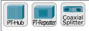

* **End Devices:**

An end device is either the source or destination of a message transmitted over the network.

* Computers (workstations, laptops, file servers, and web servers)
* Network printers
* VoIP phones
* TelePresence endpoints
* Security cameras
* Mobile handheld devices



**Result:** Successfully studied about all the devices.

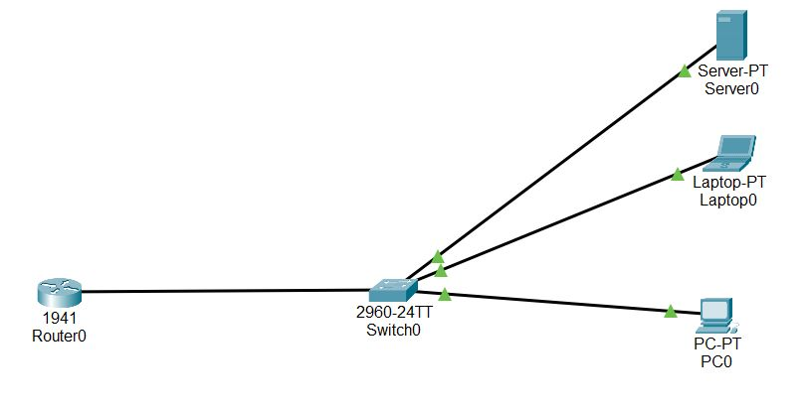

**Today’s Lab Work:**

**Evaluation Table: -**

|  |  |  |  |
| --- | --- | --- | --- |
| **Criteria** | **Total Marks** | **Marks Obtained** | **Comments** |
| Concept (A) | 2 |  |  |
| Implementation (B) | 2 |  |  |
| Performance (C) | 2 |  |  |
| Total | 6 (To be scaled down to 1) | | |

**Practical 2 Date: 18/07/2023**

**AIM:** To Configure initial Switch Settings.

**Devices Used**: Switches, PCs, and Cable**s**

**Objectives**

Part 1: Verify the Default Switch Configuration

Part 2: Configure a Basic Switch Configuration

Part 3: Configure a MOTD Banner

Part 4: Save Configuration Files to NVRAM

Part 5: Configure S2

Part 1: Verify the Default Switch Configuration

Step 1: Enter privileged EXEC mode.

Step 2: Examine the current switch configuration.

Part 2: Create a Basic Switch Configuration

Step 1: Assign a name to a switch.

Step 2: Secure access to the console line.

Step 3: Verify that console access is secured.

Step 4: Secure privileged mode access.

Step 5: Verify that privileged mode access is secure.

Step 6: Configure an encrypted password to secure access to privileged mode.

Step 7: Verify that the enable secret password is added to the configuration file.

Step 8: Encrypt the enable and console passwords.

**Q.) What is Cisco Enable Secret Password (Encrypted Privileged Exec Password)?**

Ans) The "enable secret" password in Cisco networking refers to the password used to protect access to privileged EXEC mode, which is a higher level of command-line access with more advanced configuration and management capabilities. This password is used to restrict unauthorized users from gaining elevated privileges on Cisco networking devices, such as routers and switches.

**Q.)** **If** you **configure any more passwords on the switch, will they be displayed in the configuration file as plain text**

**or in encrypted form? Explain.**

**Ans)** When we configure additional passwords on a Cisco switch or any other Cisco networking device, the passwords will be stored in the configuration file in encrypted form, not as plain text. This is a security measure to prevent unauthorized access to sensitive information, such as passwords, in case someone gains access to the configuration files.

Part 3: Configure a MOTD Banner

Step 1: Configure a message of the day (MOTD) banner.

Part 4: Save and Verify Configuration Files to NVRAM

Step 1: Verify that the configuration is accurate using the show run command.

**Q.) Why should every switch have a MOTD banner?**

**Ans**) A MOTD banner is a simple yet effective way to enhance the security, communication, and operational aspects of network device management.

Q.) **Which command will display the contents of NVRAM?**

**Ans**) show startup-config

**Q.) When will this banner be displayed?**

**Ans)** It's displayed at points where users are granted access to the device to ensure that they are aware of any relevant information before interacting with the system.

Part 5: Configure S2

**Procedure:** Open the activity through the Cisco Packet Tracer (2.5.5)

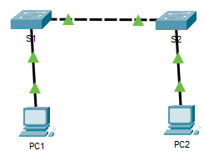

Fig. Diagram Representing connection between devices.

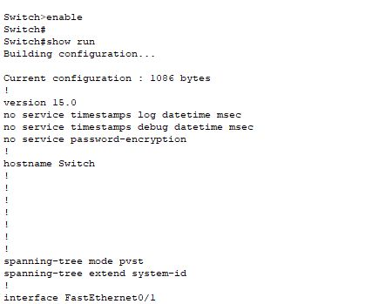 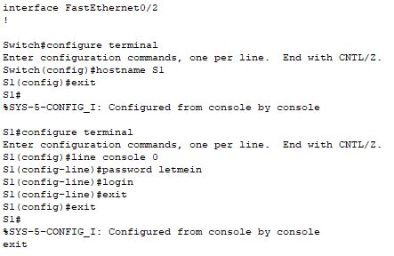

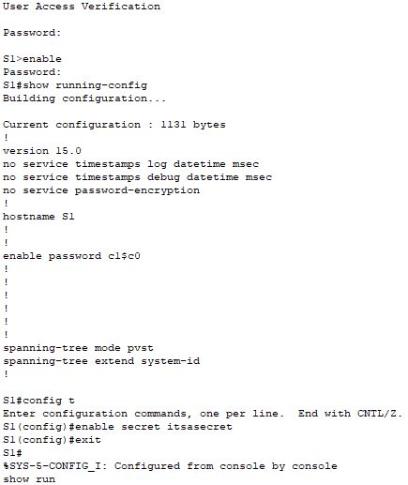 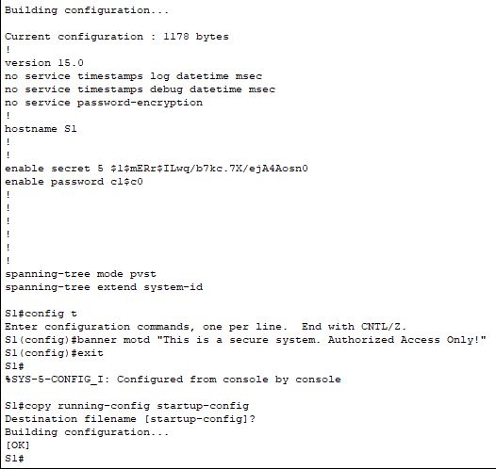

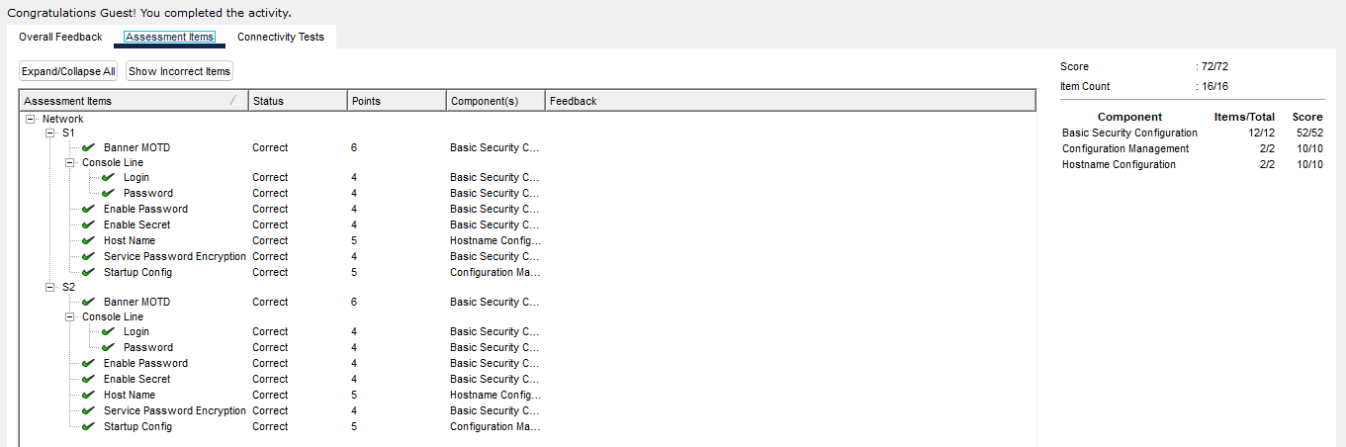**Result:**

**Evaluation Table: -**

|  |  |  |  |
| --- | --- | --- | --- |
| **Criteria** | **Total Marks** | **Marks Obtained** | **Comments** |
| Concept (A) | 2 |  |  |
| Implementation (B) | 2 |  |  |
| Performance (C) | 2 |  |  |
| Total | 6 (To be scaled down to 1) | | |

**Practical 3 Date: 25/07/2023**

**AIM:** To implement basic connectivity.

**Devices Used**: Switches, PCs, and Cable**s**

**Objectives**

Part 1: Perform a Basic Configuration on S1 and S2

Part 2: Configure the PCs

Part 3: Configure the Switch Management Interface

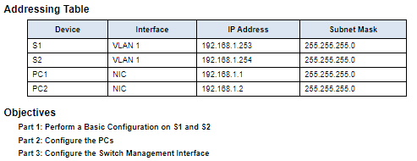

Fig. Addressing Table

Part 1: Perform a Basic Configuration on S1 and S2

Step 1: Configure S1 with a hostname. Step 2: Configure the console and encrypted privileged EXEC mode passwords.

Step 3: Verify the password configurations for S1.

Step 4: Configure an MOTD banner.

Step 5: Save the configuration file to NVRAM.

Step 6: Repeat Steps 1 to 5 for S2.

Part 2: Configure the PCs

Step 1: Configure both PCs with IP addresses.

Step 2: Test connectivity to switches.

Part 3: Configure the Switch Management Interface

Step 1: Configure S1 with an IP address.

Step 2: Configure S2 with an IP address.

Step 3: Verify the IP address configuration on S1 and S2.

Step 4: Save configurations for S1 and S2 to NVRAM.

Step 5: Verify network connectivity.

**Q.) Which command do you issue to accomplish this step?**

**Ans)** copy running-config startup-config

**Q.) Why do you enter the no shutdown command?**

**Ans)** The no shutdown command is used within the interface configuration mode to enable the interface "GigabitEthernet0/1".

**Procedure:** Open the activity through the Cisco Packet Tracer (2.7.6)

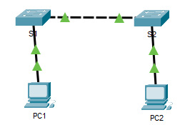

Fig. Diagram Representing Connection Between Devices

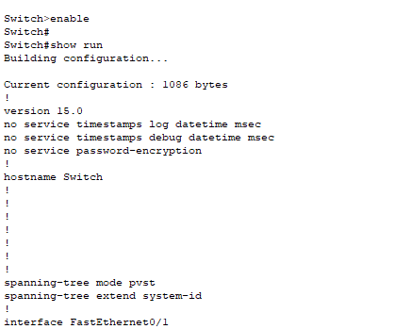 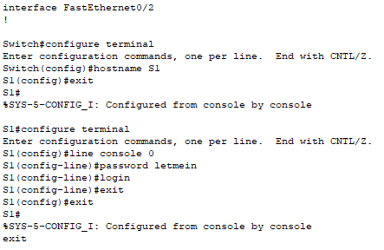

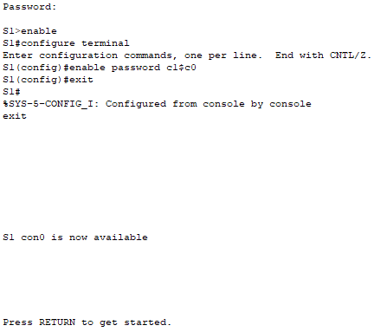 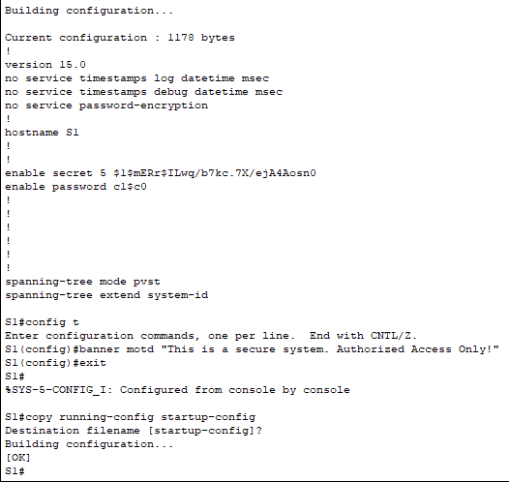

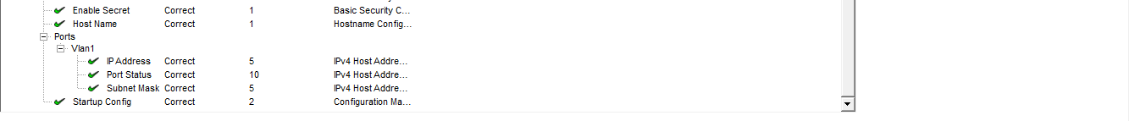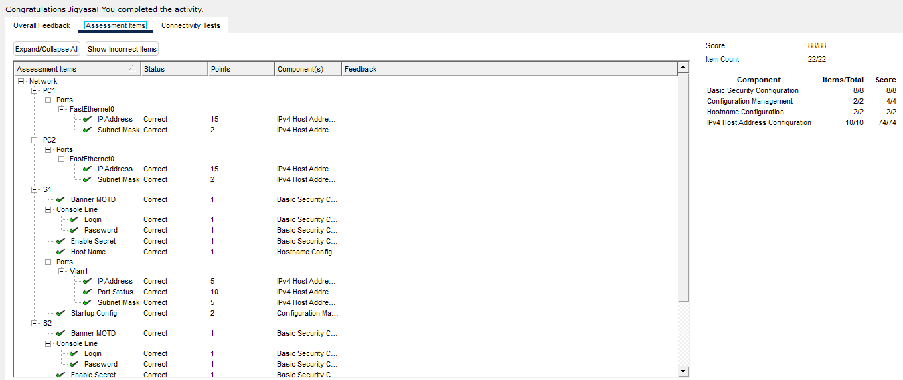**Result:**

**Evaluation Table: -**

|  |  |  |  |
| --- | --- | --- | --- |
| **Criteria** | **Total Marks** | **Marks Obtained** | **Comments** |
| Concept (A) | 2 |  |  |
| Implementation (B) | 2 |  |  |
| Performance (C) | 2 |  |  |
| Total | 6 (To be scaled down to 1) | | |

**Practical 4 Date: 25/07/2023**

**AIM:** Basic switch and end device configuration.

**Devices Used**: Switches, PCs, and Cable**s.**

**Objectives**

Part 1: Set Up the Network Topology

Part 2: Configure PC Hosts

Part 3: Configure and Verify Basic Switch Settings

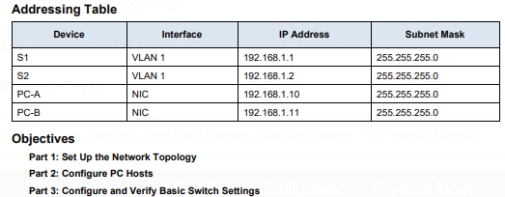

Fig. Addressing Table

**Q.) Why are some FastEthernet ports on the switches up while others are down?**

Ans) The state of a port depends on various factors, and here are some common reasons why some FastEthernet ports might be up while others are down:

* Administrative Shutdown: If a FastEthernet port is in a "down" state, it might have been intentionally administratively shut down using the shutdown command in the interface configuration.
* Configuration Errors: Configuration errors, such as incorrect IP addressing, VLAN assignment, or security settings, can result in an interface being down. Misconfigured interfaces might not be able to establish a valid link, leading to the "down" state.
* Cable or Hardware Issues: Physical problems, such as faulty cables, damaged connectors, or hardware issues, can prevent an interface from establishing a link with the connected device. This can cause the port to remain in a "down" state.
* Link Status: The link status of an interface depends on whether a valid link has been established with the connected device. If the connected device (like another switch, router, or computer) is powered off, its interface might not be able to establish a link, resulting in the "down" state.
* Speed and Duplex Mismatch: If the speed and duplex settings of two connected interfaces do not match, it can lead to connectivity issues and cause the interface to remain down.
* STP (Spanning Tree Protocol) Blocking: In a redundant network topology, STP might temporarily block certain interfaces to prevent loops. These blocked interfaces will be in a "down" state until they are unblocked by the STP protocol.
* Auto-negotiation Issues: Auto-negotiation, which allows devices to automatically determine the best link settings, can sometimes fail. This can result in an interface being down if the auto-negotiation process is not successful.

**Q.) What could prevent a ping from being sent between the PCs?**

**Ans)** Given below are few reasons that could prevent a ping from being sent between the two PCs :

* Network Connectivity Issues
* IP Address Conflicts
* Incorrect Subnet Mask
* Firewall Settings
* Switch or Router Configuration
* Routing and Gateway Issues
* Network Load or Congestion
* Remote PC Settings

**Procedure:** Open the activity through the Cisco Packet Tracer (2.9.2)

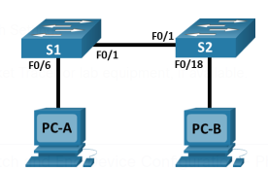

Fig. Diagram representing connection between devices.

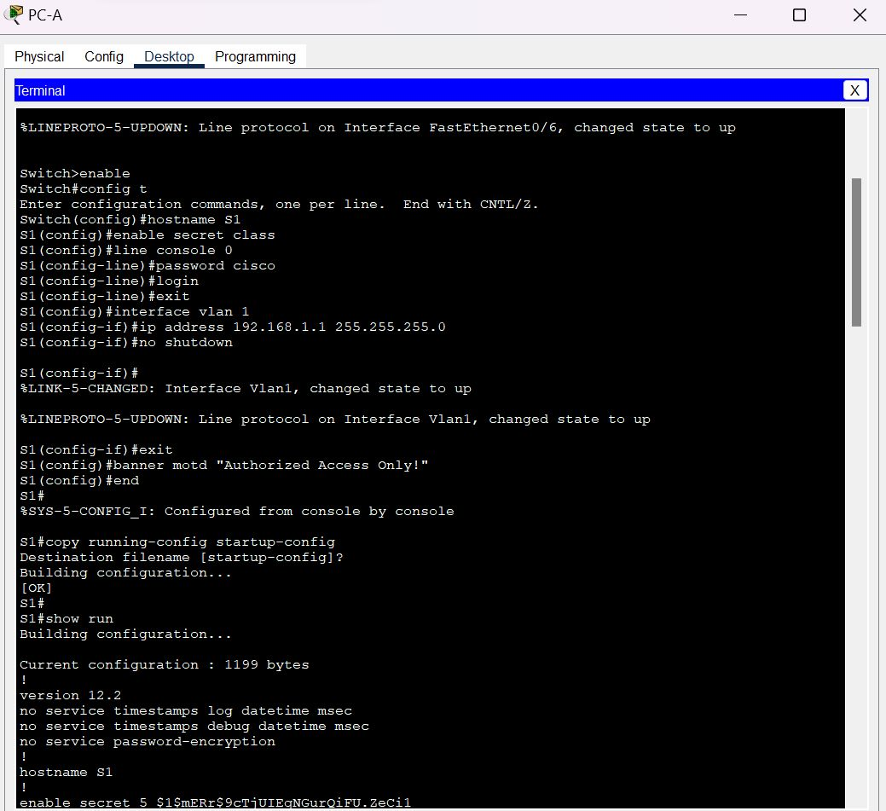 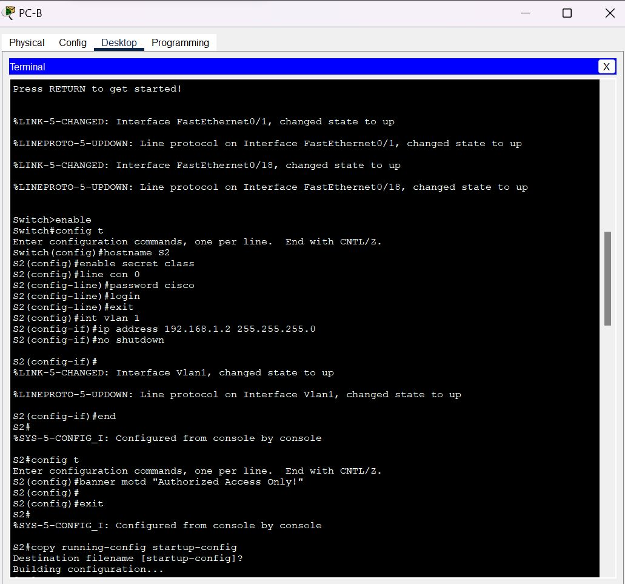

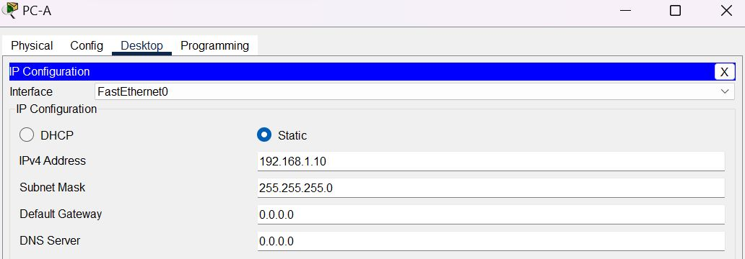

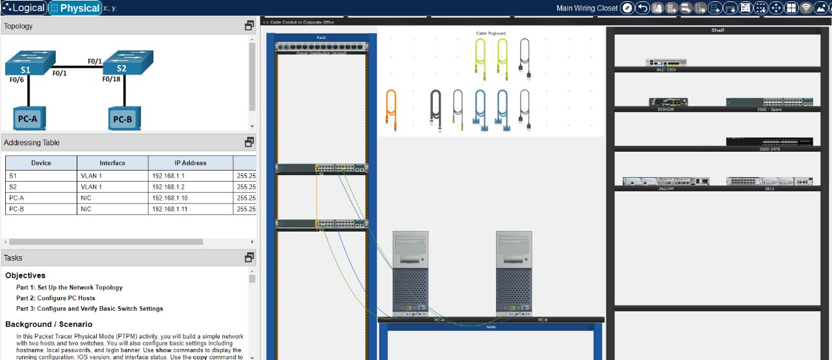

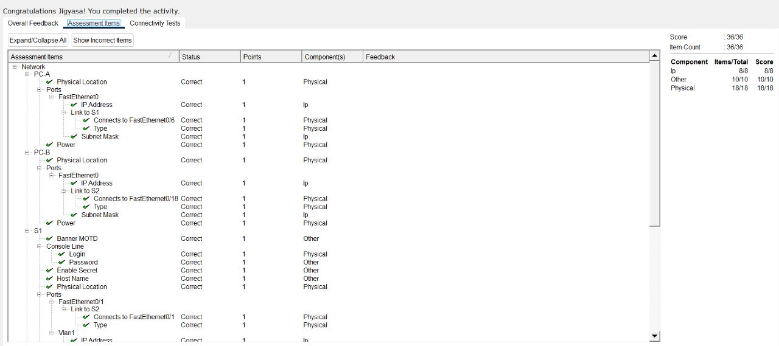**Result**:

**Evaluation Table: -**

|  |  |  |  |
| --- | --- | --- | --- |
| **Criteria** | **Total Marks** | **Marks Obtained** | **Comments** |
| Concept (A) | 2 |  |  |
| Implementation (B) | 2 |  |  |
| Performance (C) | 2 |  |  |
| Total | 6 (To be scaled down to 1) | | |
|  |  | | |

**Practical 5 Date: 22/08/2023**

**Aim:** To connect a wired and wireless LAN.

**Devices Used**: Switches, PCs, and Cable**s**

**Objectives**

Part 1: Connect to the Cloud

Part 2: Connect Router0

Part 3: Connect Remaining Devices

**Background:**

When working in Packet Tracer (a lab environment or a corporate setting), you should know how to

select the appropriate cable and how to properly connect devices. This activity will examine device

configurations in Packet Tracer, selecting the proper cable based on the configuration, and connecting

the devices. This activity will also explore the physical view of the network in Packet Tracer

**Figure:**

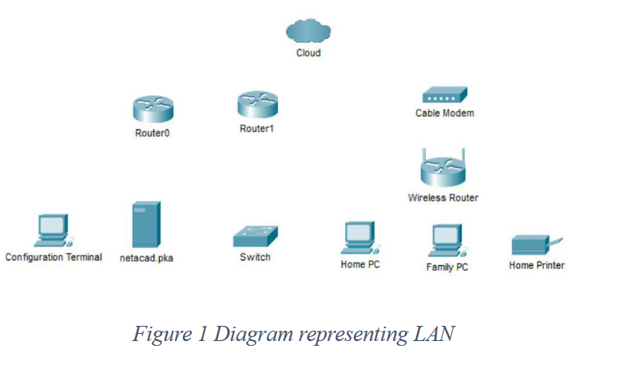

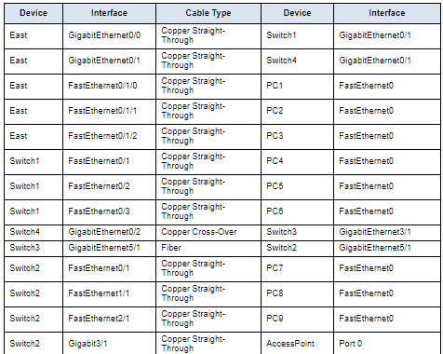**Addressing Table**:

Fig. Reference Table for connecting devices.

.

**Procedure:**

**Part 1: Connect to the Cloud**

**Step 1: Connect the cloud to Router0.**

a. At the bottom left, click the orange lightning icon to open the available Connections.

b. Choose the correct cable to connect Router0 F0/0 to Cloud Eth6. Cloud is a type of switch,

so use a Copper Straight-Through connection. If you attached the correct cable, the link

lights on the cable turn green.

**Step 2: Connect the cloud to Cable Modem.**

Choose the correct cable to connect Cloud Coax7 to Modem Port0.

If you attached the correct cable, the link lights on the cable turn green.

**Part 2: Connect Router0**

**Step 1: Connect Router0 to Router1.**

Choose the correct cable to connect Router0 Ser0/0/0 to Router1 Ser0/0. Use one of the

available Serial cables.

If you attached the correct cable, the link lights on the cable turn green.

**Step 2: Connect Router0 to netacad.pka.**

Choose the correct cable to connect Router0 F0/1 to netacad.pka F0. Routers and computers

traditionally use the same wires to transmit (1 and 2) and receive (3 and 6). The correct cable to

choose consists of these crossed wires. Although many NICs can now autosense which pair is

used to transmit and receive, Router0 and netacad.pka do not have autosensing NICs.

If you attached the correct cable, the link lights on the cable turn green.

**Step 3: Connect Router0 to the Configuration Terminal.**

Choose the correct cable to connect Router0 Console to Configuration Terminal RS232. This

cable does not provide network access to Configuration Terminal, but allows you to

configure Router0 through its terminal.

If you attached the correct cable, the link lights on the cable turn black.

**Part 3: Connect Remaining Devices**

**Step 1: Connect Router1 to Switch.**

Choose the correct cable to connect Router1 F1/0 to Switch F0/1.

If you attached the correct cable, the link lights on the cable turn green. Allow a few seconds for

the light to transition from amber to green.

**Step 2: Connect Cable Modem to Wireless Router.**

Choose the correct cable to connect Cable Modem Port1 to Wireless Router Internet port.

If you attached the correct cable, the link lights on the cable will turn green.

**Step 3: Connect Wireless Router to Family PC.**

Choose the correct cable to connect Wireless Router Ethernet 1 to Family PC.

If you attached the correct cable, the link lights on the cable turn green

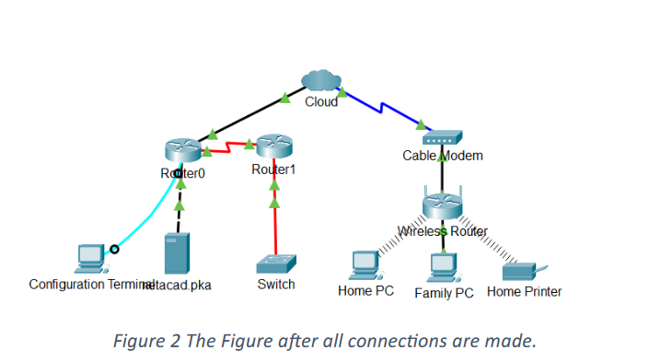

**Result**:

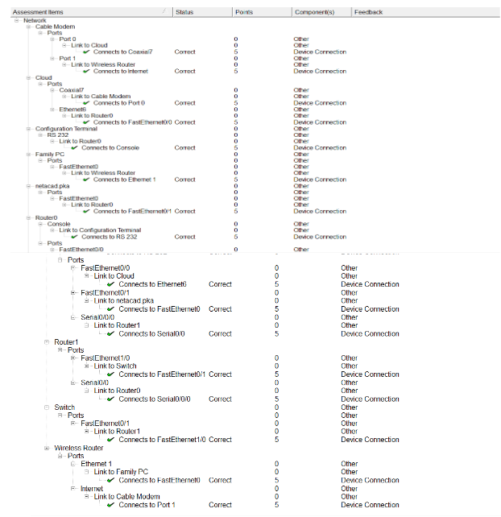

**Evaluation Table: -**

|  |  |  |  |
| --- | --- | --- | --- |
| **Criteria** | **Total Marks** | **Marks Obtained** | **Comments** |
| Concept (A) | 2 |  |  |
| Implementation (B) | 2 |  |  |
| Performance (C) | 2 |  |  |
| Total | 6 (To be scaled down to 1) | | |

**Practical 5 Date: 12/09/2023**

**AIM:** To connect the physical layer.

**Devices Used**: Switches, PCs, and Cable**s**

Objectives

Part 1: Identify Physical Characteristics of Internetworking Devices

Part 2: Select Correct Modules for Connectivity

Part 3: Connect Devices

Part 4: Check Connectivity

Part 1: Identify Physical Characteristics of Internetworking Devices

Step 1: Identify the management ports of a Cisco router.

Step 2: Identify the LAN and WAN interfaces of a Cisco router.

Step 3: Identify module expansion slots.

Part 2: Select Correct Modules for Connectivity

Step 1: Determine which modules provide the required connectivity.

Step 2: Add the correct modules and power up devices.

Part 3: Connect Devices

Fig. Reference Table for connecting devices.

Part 4: Check Connectivity

Step 1: Check the interface status on East.

Step 2: Connect wireless devices, Laptop and TabletPC

Step 3: Change the access method of the TabletPC.

Step 4: Check connectivity of the other PCs.

**Q.) Which management ports are available?**

Ans) AUX and console ports are available.

**Q.) Which LAN and WAN interfaces are available on the East router and how many are there?**

Ans) There are 2 WAN interfaces and 2 Gigabit Ethernet interfaces.

**Q.) How many physical interfaces are listed?**

Ans) 4

**Q.) What is the default bandwidth of this interface?**

Ans) 1000000 Kbit

**Q.) Click Switch2. How many expansion slots are available?**

Ans) 5 slots are available.

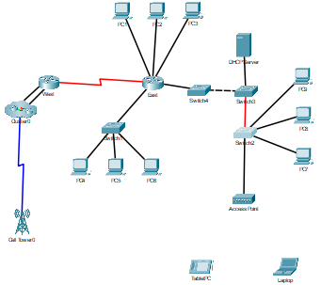

Fig. Diagram with all the connections

**Result**:

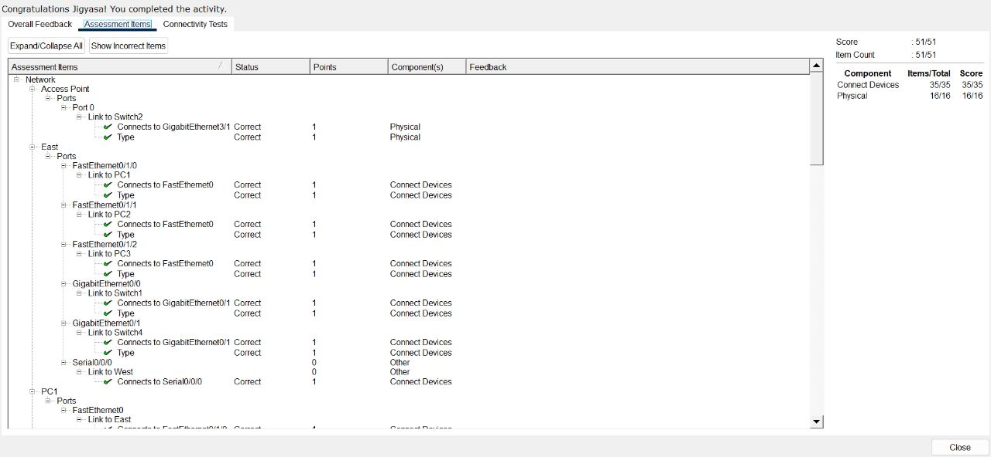

**Evaluation Table: -**

|  |  |  |  |
| --- | --- | --- | --- |
| **Criteria** | **Total Marks** | **Marks Obtained** | **Comments** |
| Concept (A) | 2 |  |  |
| Implementation (B) | 2 |  |  |
| Performance (C) | 2 |  |  |
| Total | 6 (To be scaled down to 1) | | |

**Practical 7 Date: 19/09/2023**

**Aim:** To view Network Device MAC Addresses

**Devices Used**: Switch, PCs, and Cable**s**

**Objectives**

Part 1: Configure Devices and Verify Connectivity

Part 2: Display, Describe, and Analyze Ethernet MAC Addresses

**Background:**

Every device on an Ethernet LAN is identified by a Layer 2 MAC address. This address is assigned by the

manufacturer and stored in the firmware of the NIC. This lab will explore and analyze the components that

make up a MAC address, and how you can find this information on a switch and a PC.

You will cable the equipment as shown in the topology. You will configure the switch and PC to match the

addressing table. You will verify your configurations by testing for network connectivity.

After the devices have been configured and network connectivity has been verified, you will use various

commands to retrieve information from the devices to answer questions about your network equipment.

**Figure**:

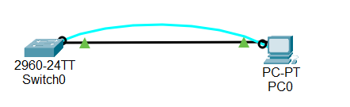

**Addressing Table**:

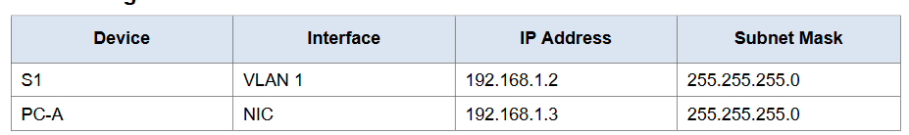

**Procedure**:

**Part 1: Configure Devices and Verify Connectivity**.

Step 1: Cable the network as shown in the topology.

Step 2: Configure the IPv4 address for the PC.

Step 3: Configure basic settings for the switch.

**Part 2: Display, Describe, and Analyze Ethernet MAC Addresses**

Step 1: Analyze the MAC address for the PC-A NIC.

Step 2: Analyze the MAC address for the S1 F0/6 interface.

Step 3: View the MAC addresses on the switch.

**Questions:**

**Q) Were the pings successful?**

Ans) Yes, the ping from PC to Switch were successful with 0% loss.

**Q) What is the MAC address for VLAN 1 on S1?**

Ans) 000b.be7e.67e7

**Q.) What is the MAC serial number for VLAN 1 on S1?**

Ans) 001b.0c6d.8f40

**Q.) What is OUI for VLAN 1?**

Ans) 001.0c6d

**Q.) What does bia stand for?**

Ans) The MAC address is often referred to as a burned-in address (BIA) because,

historically, this address is burned into ROM (Read-Only Memory) on the NIC.

**Q.) What is the Layer 2 address displayed on S1?**

Ans) 192.168.1.2

**Result:**

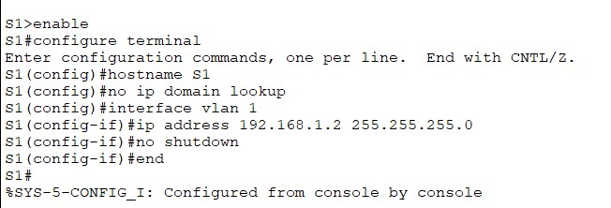

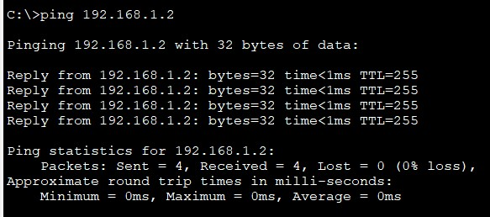

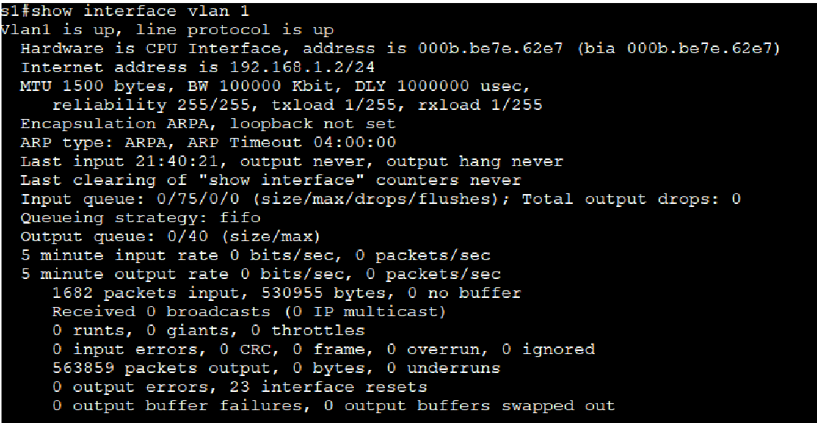



**Evaluation Table: -**

|  |  |  |  |
| --- | --- | --- | --- |
| **Criteria** | **Total Marks** | **Marks Obtained** | **Comments** |
| Concept (A) | 2 |  |  |
| Implementation (B) | 2 |  |  |
| Performance (C) | 2 |  |  |
| Total | 6 (To be scaled down to 1) | | |

**Practical 8 Date: 26/09/2023**

**Aim:** To perform basic and initial router configuration

**Devices Used**: Router, PCs, and Console Cable.

**Objectives:**

Part 1: Verify the Default Router Configuration

Part 2: Configure and Verify the Initial Router Configuration

Part 3: Save the Running Configuration File

**Background:**

In this activity, you will perform basic router configuration tasks. You will secure access to the CLI and console port using encrypted and plain-text passwords. You will also configure messages for users who are logging into the router. These banners warn unauthorized users that access is prohibited. Finally, you will verify and save your running configuration.

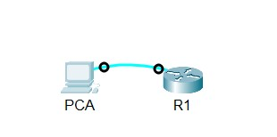

**Figure**:

**Procedure**:

**Part 1: Verify the Default Router Configuration**

**Step 1: Establish a console connection to R1**.

a. Choose a Console cable from the available connections.

b. Click PCA and select RS 232.

c. Click R1 and select Console.

d. Click PCA > Desktop tab > Terminal.

e. Click OK and press ENTER. You are now able to configure R1.

**Part 2: Configure and Verify the Initial Router Configuration**

**Step 1: Perform initial router configuration**

Router> enable

Router# show running-config

Router# show startup-config

Router# configure terminal

Router(config) hostname R1

R1(config)# banner motd #Unauthorized access is strictly prohibited#

R1(config)#enable password cisco

R1(config)#enable secret itsasecret

R1(config)#line console 0

R1(config)#password letmein

R1(config)#login

R1(config)#service password-encyrption

R1(config)#exit

R1#show running-config

R1#copy running-config startup-config

R1# exit

**Step 2:Verify the initial router configuration**

Verify the initial settings by viewing the configuration for R1.

Type your answers here.

b. Exit the current console session until you see the following message:

R1 con0 is now available

Press RETURN to get started.

c. Press ENTER; you should see the following message:

Unauthorized access is strictly prohibited.

User Access Verification

Password:

**Part 3: Save Running Configuration to NVRAM file**

You have configured the initial settings for R1. Now back up the running configuration file to NVRAM to

ensure that the changes made are not lost if the system is rebooted or loses power.

**Questions:**

**Q) What is the router’s hostname?**

Ans) Router

**Q) How many Fast Ethernet interfaces does the Router have?**

Ans) 4

**Q) How many Gigabit Ethernet interfaces does the Router have?**

Ans) 2

**Q) How many Serial interfaces does the router have?**

Ans) 2

**Q) What is the range of values shown for the vty lines?**

Ans) 0-4

**Q) What command do you use to verify initial configuration on router?**

Ans) show running-config

**Q) Why should every router have a message-of-the-day (MOTD) banner?**

Ans) Every router should have a banner to warn unauthorized users that access is prohibited. MOTD Banners can also be used to send messages to network personnel (such as impending system shutdowns or who to contact for access).

**Q) f you are not prompted for a password before reaching the user EXEC prompt, what console line command did you forget to configure?**

Ans) R1(config-line)# login

**Q) If you configure any more passwords on the router, are they displayed in the configuration file as plain text or in encrypted form? Explain.**

Ans) The service password-encryption command encrypts all current and future passwords.

**Q) What command did you enter to save the configuration to NVRAM?**

Ans) copy running-config startup-config

**Q) Which command displays the contents of the NVRAM?**

Ans) show startup-configuration or show start

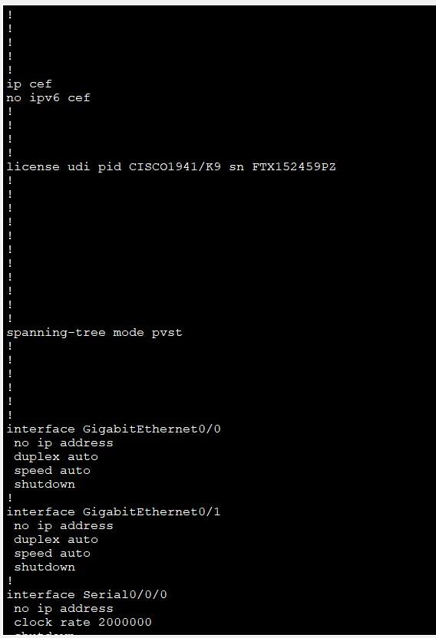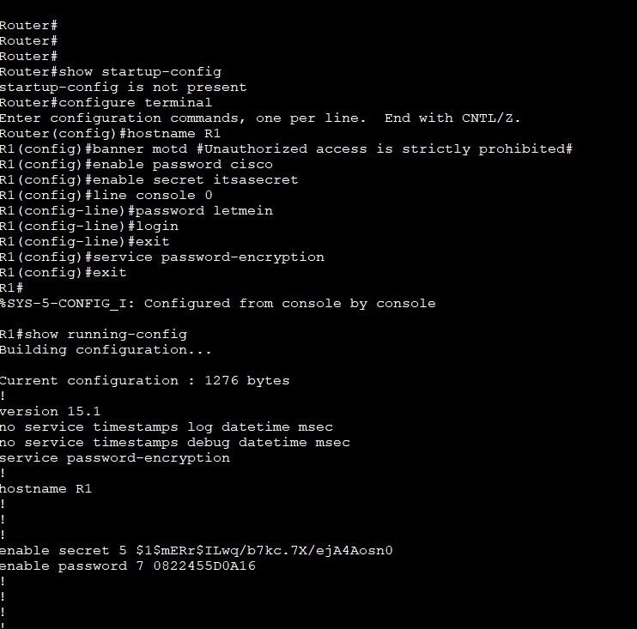**Result**:

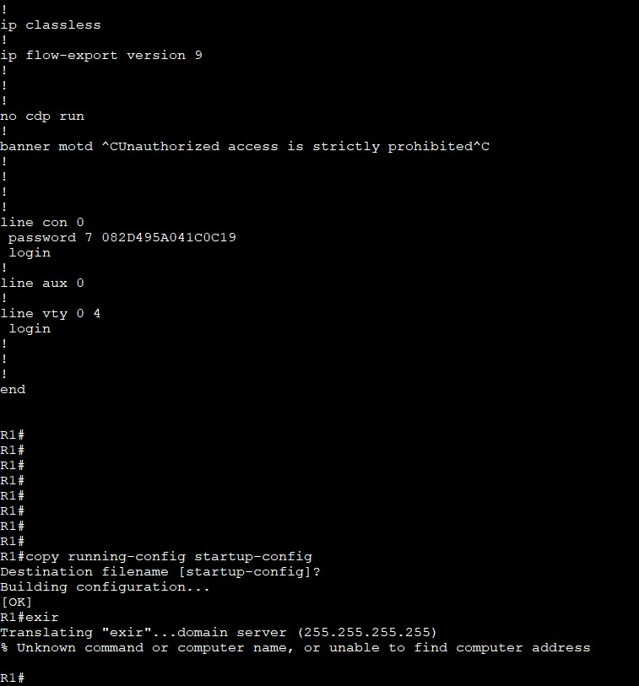

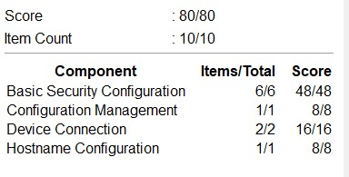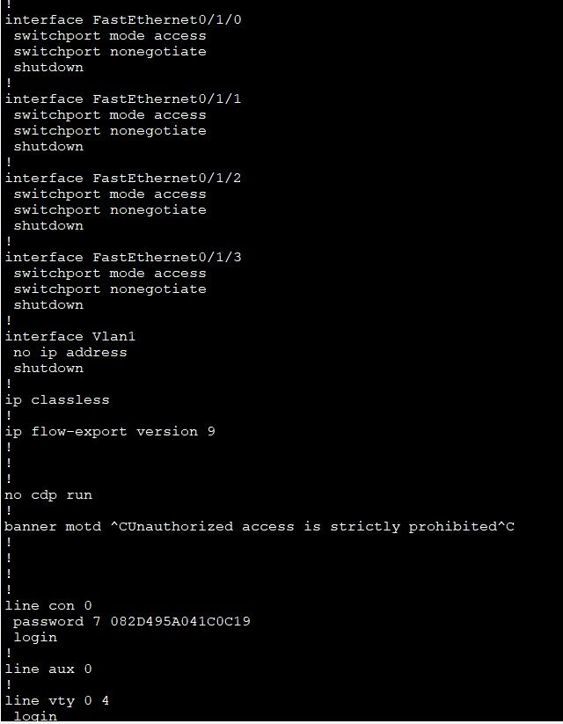

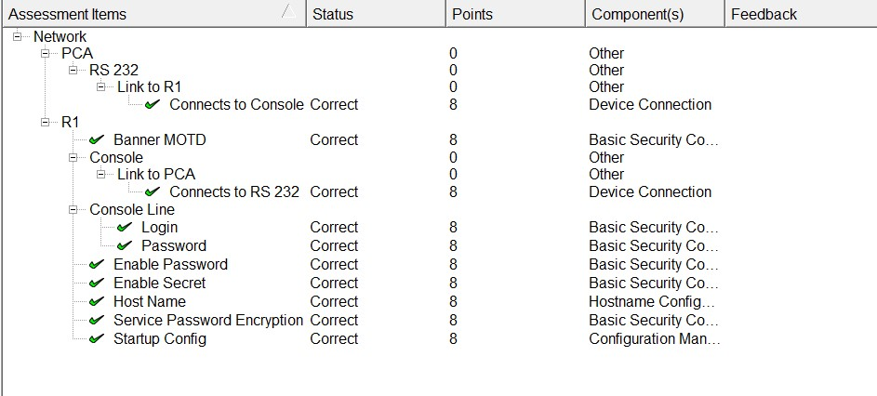

**Evaluation Table: -**

|  |  |  |  |
| --- | --- | --- | --- |
| **Criteria** | **Total Marks** | **Marks Obtained** | **Comments** |
| Concept (A) | 2 |  |  |
| Implementation (B) | 2 |  |  |
| Performance (C) | 2 |  |  |
| Total | 6 (To be scaled down to 1) | | |

**Practical 9 Date: 26/09/2023**

**Aim:** To connect a router to a LAN

**Devices Used**: Router, PCs, and Cables.

**Objectives:**

Part 1: Display Router Information

Part 2: Configure Router Interfaces

Part 3: Verify the Configuration

**Background:**

In this activity, you will use various show commands to display the current state of the router. You will then

use the Addressing Table to configure router Ethernet interfaces. Finally, you will use commands to verify and

test your configurations**.**

**Addressing Table:**

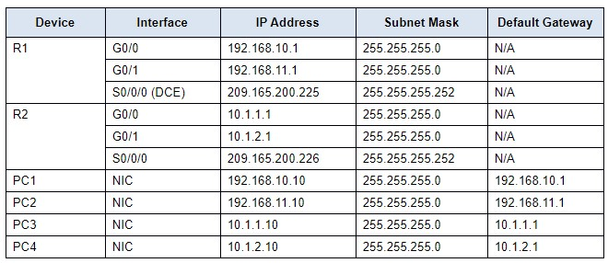

**Network Topology(Figure):**

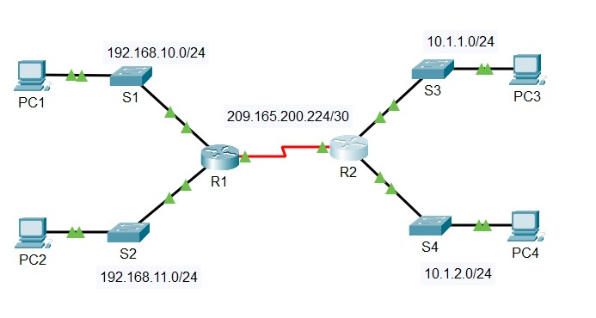

**Procedure:**

**Part 1: Display Router Information**

**Step 1: Display interface information on R1.**

Click a device and then click the CLI tab to access the command line directly. The console password is

cisco. The privileged EXEC password is class. Enter the command to display the statistics for the Serial 0/0/0 interface on R1.

**Step 2: Display a summary list of the interfaces on R1**

Enter the router configuration commands along with commands for Ethernet Interfaces. Use command show ip interface brief for the same.

**Step 3: Display the routing table on R1**

Use command show ip route to display the routing table on R1.

**Part 2: Configure Router Interfaces**

**Step 1:** **Configure the GigabitEthernet 0/0 interface on R1**

R1(config)# interface gigabitethernet 0/0

R1(config-if)# ip address 192.168.10.1 255.255.255.0

R1(config-if)# no shutdown

%LINK-5-CHANGED: Interface GigabitEthernet0/0, changed state to up

%LINEPROTO-5-UPDOWN: Line protocol on Interface GigabitEthernet0/0, changed

state to up

**Step 2: Configure the remaining Gigabit Ethernet Interfaces on R1 and R2.**

Use the information in the Addressing Table to finish the interface configurations for R1 and R2.

**Step 3: Back up the configurations to NVRAM**

For this use the command copy running config startup config to back up the configurations.

**Part 3: Verify the Configuration**

**Step 1: Use verification commands to check your interface configurations.**

a. Use the show ip interface brief command on both R1 and R2 to quickly verify that the interfaces are

configured with the correct IP address and are active.

**Step 2: Test end-to-end connectivity across the network.**

You should now be able to ping from any PC to any other PC on the network. In addition, you should be able

to ping the active interfaces on the routers. For example, the following tests should be successful:

• From the command line on PC1, ping PC4.

• From the command line on R2, ping PC2.

**Commands:**

**R1:**

R1>enable

class

R1#config terminal

R1(config)#interface gigabitethernet 0/0

R1(config-if)#ip address 192.168.10.1 255.255.255.0

R1(config-if)#no shutdown

R1(config-if)#description LAN connection to S1

R1(config-if)#exit

R1(config)#interface gigabitEthernet 0/1

R1(config-if)#ip address 192.168.11.1 255.255.255.0

R1(config-if)#no shutdown

R1(config-if)#description LAN connection to S2

R1(config-if)#end

R1#copy running-config startup-config

**R2:**

R2>enable

Password: class

R2#conf terminal

R2(config)#interface gigabitEthernet 0/0

R2(config-if)#ip add 10.1.1.1 255.255.255.0

R2(config-if)#no shutdown

R2(config-if)#description LAN connection to S3

R2(config-if)#interface gigabitEthernet 0/1

R2(config-if)#ip address 10.1.2.1 255.255.255.0

R2(config-if)#no shutdown

R2(config-if)#description LAN connection to S4

R2(config-if)#end

R2#copy running-config startup-config

**Questions:**

**Q) Which command displays the statistics for all interfaces configured on a router?**

Ans) R1#show interfaces

**Q) Which command displays the information about the Serial 0/0/0 interface only?**

Ans) R1#show interfaces serial 0/0/0

**Q) What is the IP address configured on R1?**

Ans) 209.165.200.225/30

**Q) What is the bandwidth on the Serial 0/0/0 interface?**

Ans) 1544k bits

**Q) What is the IP address on R1?**

Ans) There is no IP address configured on the GigabitEthernet 0/0 interface.

**Q) What is the MAC address of the GigabitEthernet 0/0 interface?**

Ans) 000d.bd6c.7d01

**Q) What is the bandwidth on the GigabitEthernet 0/0 interface?**

Ans) 1000000 kbits

**Q) How many serial interfaces are there on R1 and R2?**Ans)Each router has 2 serial interfaces

**Q) How many Ethernet interfaces are there on R1 and R2?**Ans)R1 has 6 Ethernet interfaces and R2 has 2 Ethernet interfaces.

**Q) Are all the Ethernet interfaces on R1 the same? If no, explain the difference(s).**  
Ans)No, they are not. There are two Gigabit Ethernet interfaces and 4 Fast Ethernet interfaces. Gigabit Ethernet interfaces support speeds of up to 1,000,000,000 bits per second and Fast Ethernet interfaces support speeds of up to 1,000,000 bits per second.

**Q) How many connected routes are there (uses the C code)?**

Ans) 1

**Q) How does a router handle a packet destined for a network that is not listed in the routing table?**  
Ans)A router will only send packets to a network listed in the routing table. If a network is not listed, the packet will be dropped.

**Q) Save the configuration files on both routers to NVRAM. What command did you use?**

Ans)copy running-config startup -config

**Q) How many interfaces on R1 and R2 are configured with IP addresses and in the “up” and “up” state?**

Ans) Three on each of the router/

**Q) What part of the interface configuration is NOT displayed in the command output?**

Ans)The subnet mask.

**Q) What commands can you use to verify this part of the configuration**?

Ans) show run, show interfaces, show ip protocols

**Q) How many OSPF routes (uses the O code) do you see on each router?**

Ans) Both R1 and R2 show 2 OSPF routes.

**Q) If the router knows all the routes in the network, then the number of connected routes and dynamically learned routes (OSPF) should equal the total number of LANs and WANs. How many LANs and WANs are in the topology?**

Ans) 5

**Q) Does this number match the number of C and O routes shown in the routing table?**

Ans) Yes, they do.

**Result:**

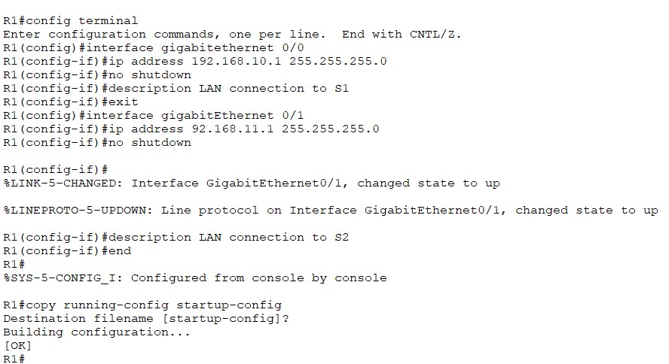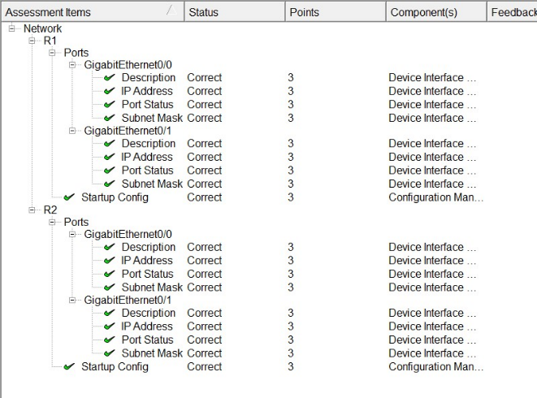

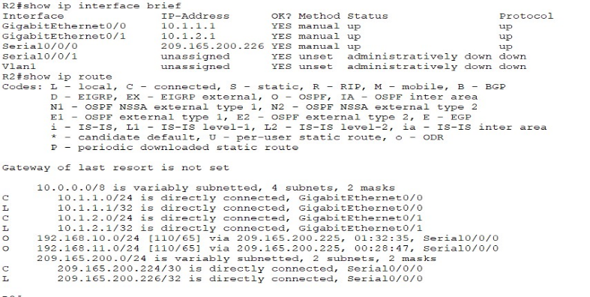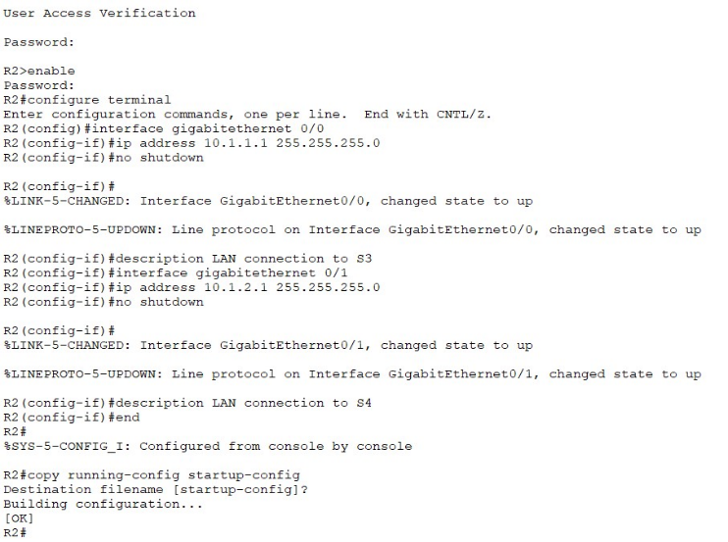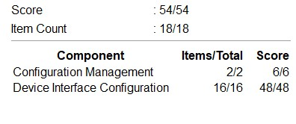

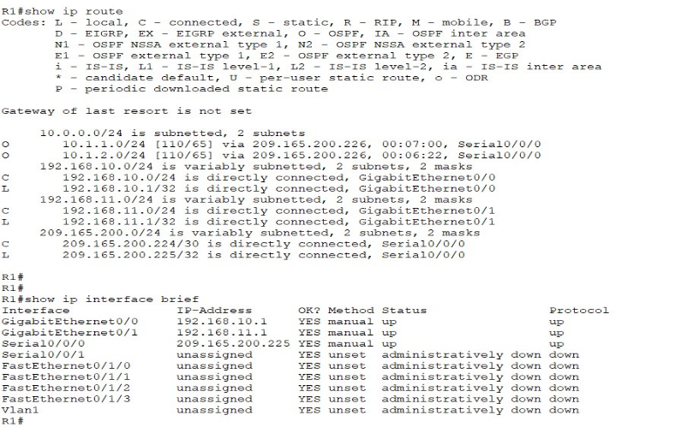

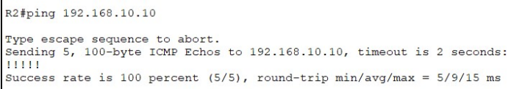

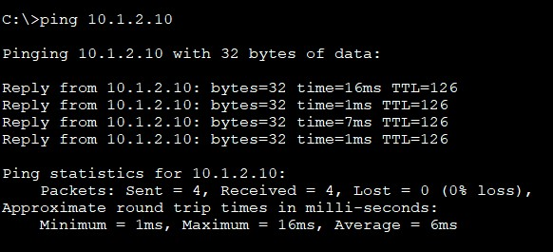

**Evaluation Table: -**

|  |  |  |  |
| --- | --- | --- | --- |
| **Criteria** | **Total Marks** | **Marks Obtained** | **Comments** |
| Concept (A) | 2 |  |  |
| Implementation (B) | 2 |  |  |
| Performance (C) | 2 |  |  |
| Total | 6 (To be scaled down to 1) | | |

**Practical 10**

**Aim:** To implement subnetting scenario.

**Devices Used**: Router, PCs, Switches and Cables.

**Objectives:**

Part 1: Design an IP Addressing Scheme

Part 2: Assign IP Addresses to Network Devices and Verify Connectivity

**Background:**

In this activity, you are given the network address of 192.168.100.0/24 to subnet and provide the IP

addressing for the Packet Tracer network. Each LAN in the network requires at least 25 addresses for end

devices, the switch and the router. The connection between R1 to R2 will require an IP address for each end

of the link.

**Addressing Table:**

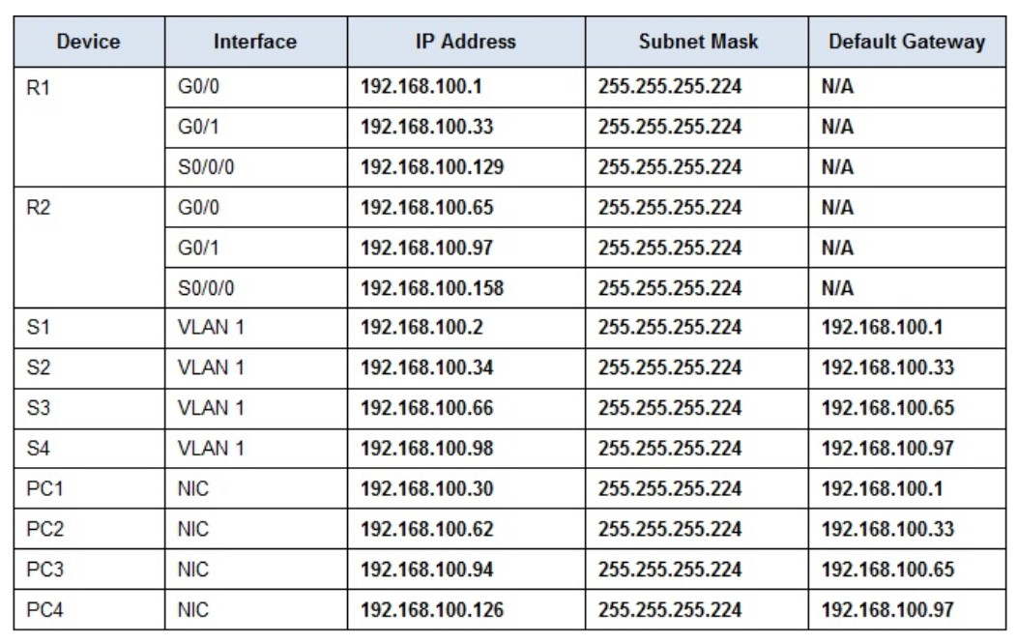

**Network Topology:**

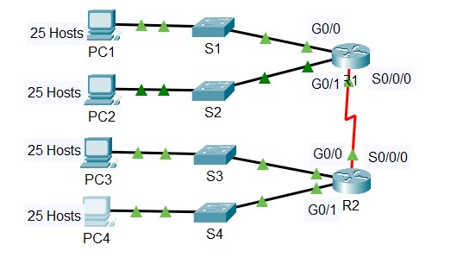

**Procedure:**

**Part 1: Design an IP Addressing Scheme**

**Step 1: Subnet the 192.168.100.0/24 network into the appropriate number of subnets**.

Calculate the binary value for the first five subnets. Calculate the binary and decimal value of the new subnet mask. Fill in the Subnet Table, listing the decimal value of all available subnets, the first and last usable host

address, and the broadcast address. Repeat until all addresses are listed.

**Step 2: Assign the subnets to the network shown in the topology.**

Assign Subnet 0 to the LAN connected to the GigabitEthernet 0/0 interface of R1:

Assign Subnet 1 to the LAN connected to the GigabitEthernet 0/1 interface of R1:

Assign Subnet 2 to the LAN connected to the GigabitEthernet 0/0 interface of R2:

Assign Subnet 3 to the LAN connected to the GigabitEthernet 0/1 interface of R2:

Assign Subnet 4 to the WAN link between R1 to R2.

**Step 3: Document the addressing scheme.**

Fill in the Addressing Table using the following guidelines:

a. Assign the first usable IP addresses in each subnet to R1 for the two LAN links and the WAN link.

b. Assign the first usable IP addresses in each subnet to R2 for the LAN links. Assign the last usable IP

address for the WAN link.

c. Assign the second usable IP address in the attached subnets to the switches.

d. Assign the last usable IP addresses to the PCs in each subnet.

**Part 2: Assign IP Addresses to Network Devices and Verify Connectivity**

**Step 1: Configure R1 LAN interfaces.**

a. Configure both LAN interfaces with the addresses from the Addressing Table.

b. Configure the interfaces so that the hosts on the LANs have connectivity to the default gateway.

**Step 2: Configure IP addressing on S3.**

a. Configure the switch VLAN1 interface with addressing.

b. Configure the switch with the default gateway address.

**Step 3: Configure PC4.**

Configure PC4 with host and default gateway addresses.

**Commands:**

**R1:**

enable

configure terminal

interface GigabitEthernet0/0

ip address 192.168.100.1 255.255.255.224

no shutdown

interface GigabitEthernet0/1

ip address 192.168.100.33 255.255.255.224

no shutdown

end

**S3:**

enable

configure terminal

interface Vlan1

ip address 192.168.100.66 255.255.255.224

no shutdown

ip default-gateway 192.168.100.65

end

**PC4:**

IP address: **192.168.100.126 /27**  
Subnet Mask: **255.255.255.224**  
Default gateway: **192.168.100.97**

**Questions:**

**Q) Based on the topology, how many subnets are needed?**

Ans) 5. 4 for LANs and 1 for link between routers.

**Q) How many bits must be borrowed to support the umber of subnets in the topology table?**

Ans) 3

**Q) How many subnets does this create?**

Ans) 8

**Q) How many usable hosts does this create per subnet?**

Ans)30

**Q) Assign Subnet 0 to the LAN connected to the GigabitEthernet 0/0 interface of R1**:

Ans) 192.168.100.0/27

**Q) Assign Subnet 1 to the LAN connected to the GigabitEthernet 0/1 interface of R1:**

Ans) 192.168.100.32/27

**Q) Assign Subnet 2 to the LAN connected to the GigabitEthernet 0/0 interface of R2:**

Ans) 192.168.100.64/27

**Q) Assign Subnet 3 to the LAN connected to the GigabitEthernet 0/1 interface of R2:**

Ans) 192.168.100.96/27

**Q) Assign Subnet 4 to the WAN link between R1 to R2:**

Ans) 192.168.100.128/27

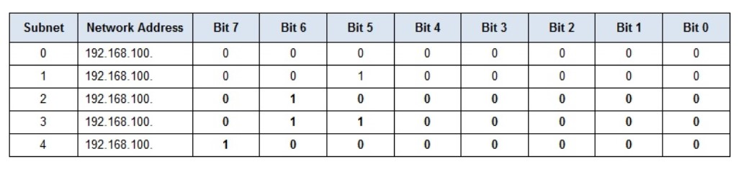**Result:**

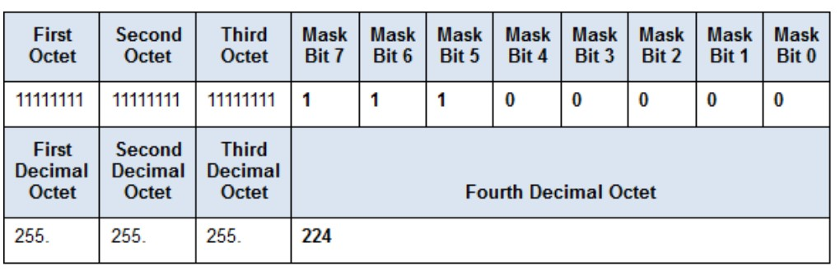

Subnet Table:

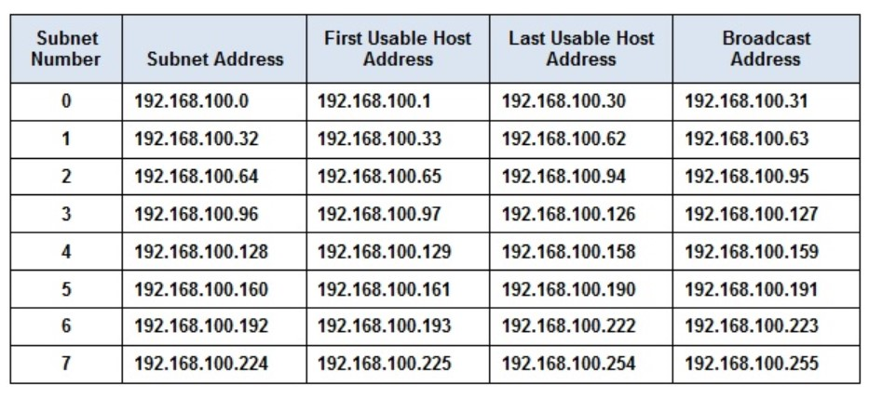

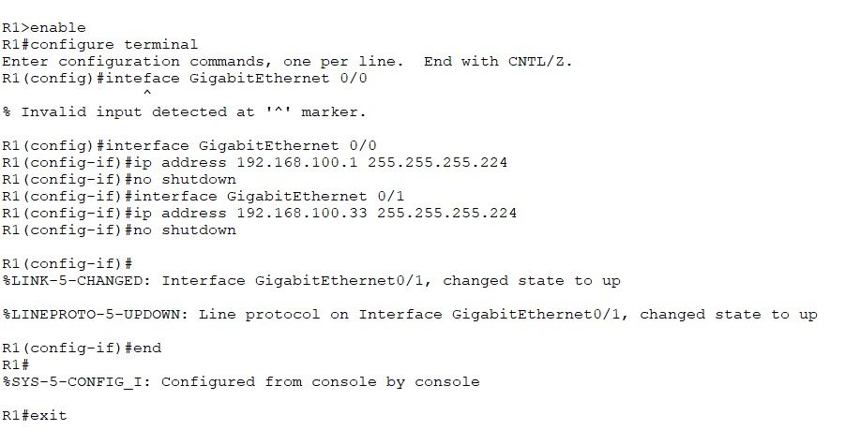

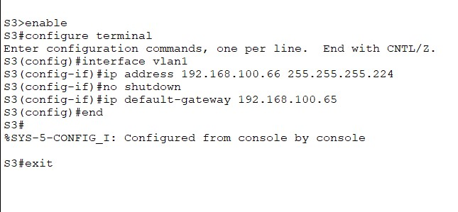

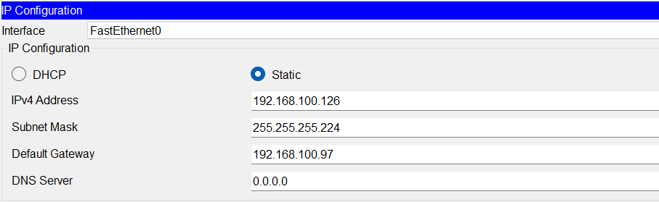

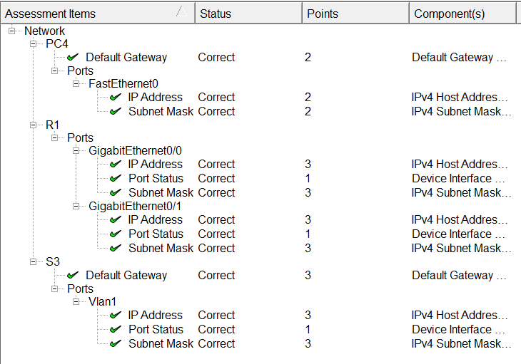

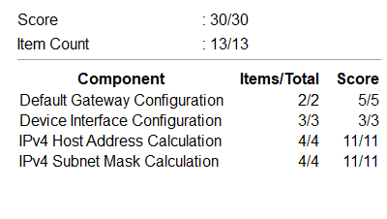

**Evaluation Table: -**

|  |  |  |  |
| --- | --- | --- | --- |
| **Criteria** | **Total Marks** | **Marks Obtained** | **Comments** |
| Concept (A) | 2 |  |  |
| Implementation (B) | 2 |  |  |
| Performance (C) | 2 |  |  |
| Total | 6 (To be scaled down to 1) | | |

**Practical 11**

**Aim:** To implement VLSM Addressing Scheme(Variable length Subnetting Scheme)

**Devices Used**: Router, PCs, Switches and Cables.

**Objectives:**

Part 1: Examine the Network Requirements

Part 2: Design the VLSM Addressing Scheme

Part 3: Assign IP Addresses to Devices and Verify Connectivity

**Background:**

In this activity, you are given a /24 network address to use to design a VLSM addressing scheme. Based on a

set of requirements, you will assign subnets and addressing, configure devices and verify connectivity.

**Addressing Table:**

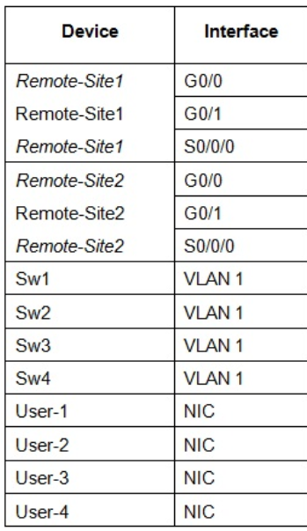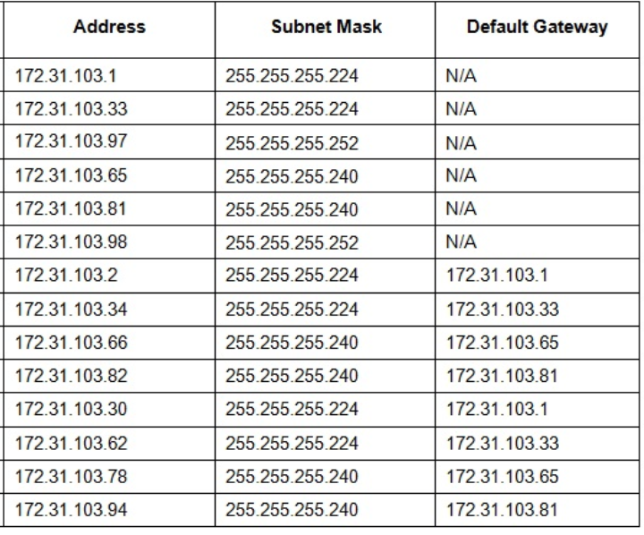

**Network Diagram(Topology):**

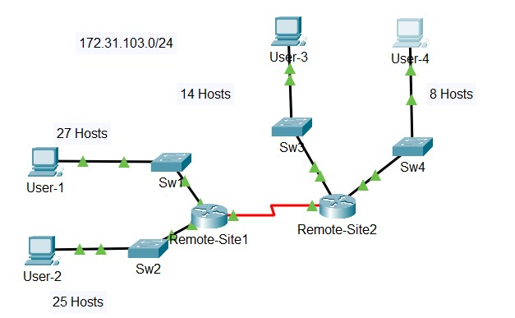

**Procedure:**

**Part 1: Examine the Network Requirements**

**Step 1: Determine the number of subnets needed.**

You will subnet the network address . The network has the following requirements:

* LAN will require host IP addresses
* LAN will require host IP addresses
* LAN will require host IP addresses
* LAN will require host IP addresses

**Step 2: Determine the subnet mask information for each subnet.**

**Part 2: Design the VLSM Addressing Scheme**

**Step 1: Divide the network based on the number of hosts per subnet.**

a. Use the first subnet to accommodate the largest LAN.

b. Use the second subnet to accommodate the second largest LAN.

c. Use the third subnet to accommodate the third largest LAN.

d. Use the fourth subnet to accommodate the fourth largest LAN.

e. Use the fifth subnet to accommodate the connection between

**Step 2: Document the VLSM subnets**

Complete the Subnet Table, listing the subnet descriptions (e.g. [[S1Name]] LAN), number of hosts needed,

then network address for the subnet, the first usable host address, and the broadcast address. Repeat until all

addresses are listed.

**Step 3: Document the addressing scheme.**

a. Assign the first usable IP addresses to for the two LAN links and the WAN link.

b. Assign the first usable IP addresses to for the two LAN links. Assign the last usable IP

address for the WAN link.

c. Assign the second usable IP addresses to the switches.

d. Assign the last usable IP addresses to the hosts.

**Part 3: Assign IP Addresses to Devices and Verify Connectivity**

Most of the IP addressing is already configured on this network. Implement the following steps to complete

the addressing configuration.

**Step 1: Configure IP addressing on the router LAN interfaces.**

**Step 2: Configure IP addressing on the , switch including the default gateway.**

**Step 3: Configure IP addressing on , including the default gateway.**

**Step 4: Verify connectivity**.

You can only verify connectivity using ping command. However, you should be able to ping every IP address listed in the Addressing Table

**COMMANDS:**

**Remote Site-1**

en

conf t

int g0/0

ip add 172.31.103.1 255.255.255.224

no shut

int g0/1

ip add 172.31.103.33 255.255.255.224

no shut

**Switch(Sw3)**

en

conf t

int vlan 1

ip add 172.31.103.66 255.255.255.240

no shut

ip def 172.31.103.65

**User-4(IP Config)**

IP Address: **172.31.103.94**  
Subnet Mask: **255.255.255.240**  
Default Gateway: **172.31.103.81**

**Result:**

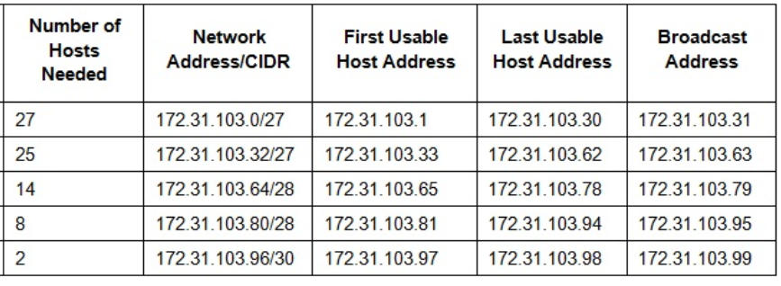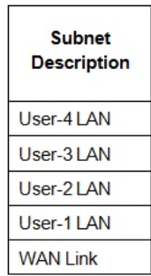

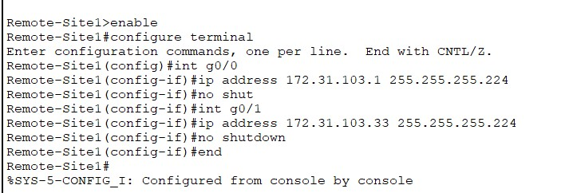

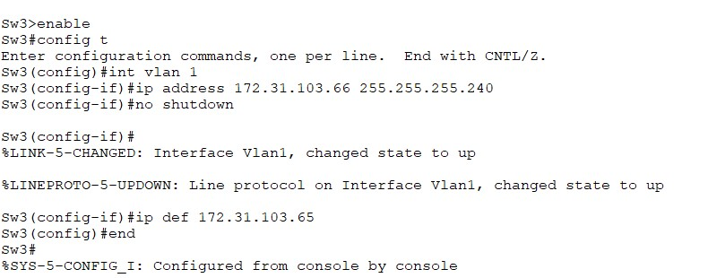

\

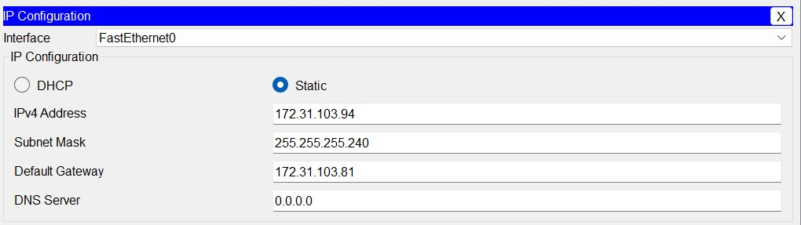

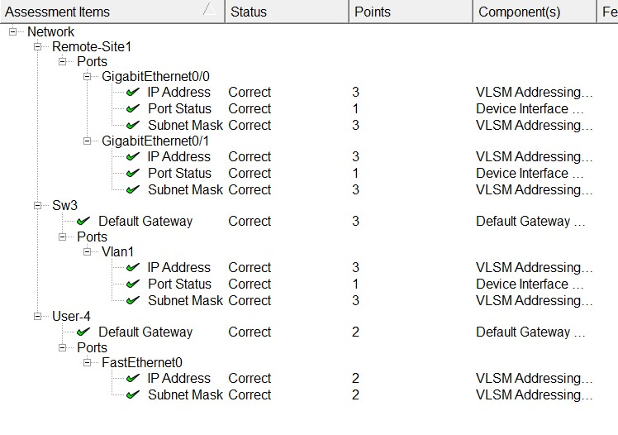

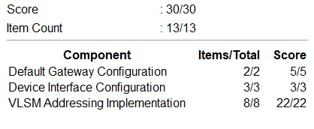

**Evaluation Table: -**

|  |  |  |  |
| --- | --- | --- | --- |
| **Criteria** | **Total Marks** | **Marks Obtained** | **Comments** |
| Concept (A) | 2 |  |  |
| Implementation (B) | 2 |  |  |
| Performance (C) | 2 |  |  |
| Total | 6 (To be scaled down to 1) | | |

**Practical 12**

**Aim:** To implement a Subnetted IPv6 Addressing Scheme

**Devices Used**: Router, PCs, Switches and Cables.

**Objectives:**

Step 1: Determine IPv6 subnets and addressing scheme.

Step 2: Configure IPv6 addressing on routers and PCs.

Step 3: Verify IPv6 connectivity.

**Background:**

Network administrators must know how to implement IPv6 in their networks. You have been asked to set up a

network for use by the sales staff for a customer demonstration. The network will use a series of consecutive

IPv6 subnets for four LANs. Your job is to assign the subnets to the LANs and configure the routers and PCs

with IPv6 addressing. Make certain to configure all the necessary components for IPv6 routing on the routers..

**Addressing Table:**

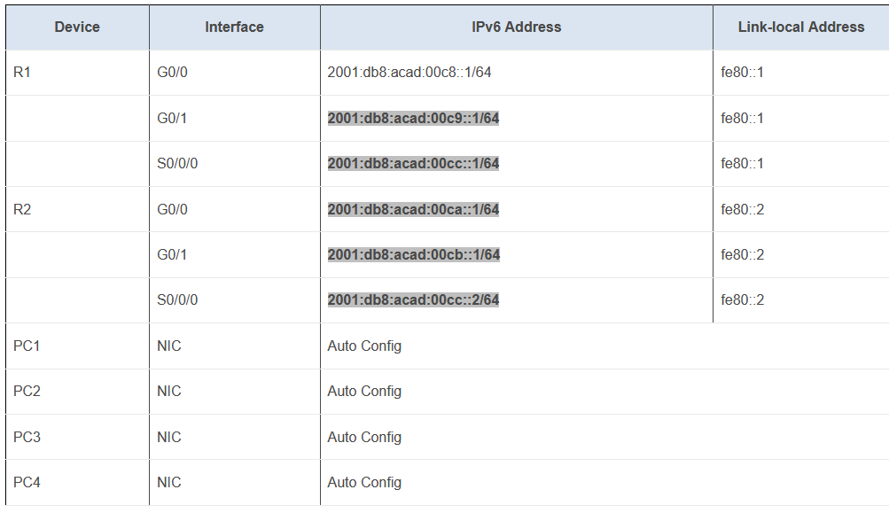

**Network Diagram(Topology):**

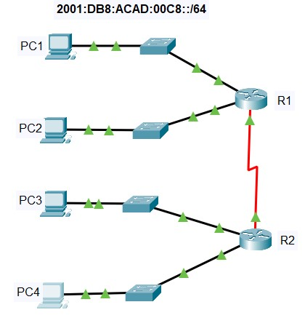

**Procedure:**

**Step 1: Determine IPv6 subnets and addressing scheme.**

You have been given the IPv6 subnet 2001:db8:acad:00c8::/64 as the starting subnet. You will need four

more subnets for each network that is required. Increment the subnet addresses consecutively by one to

arrive at the four required subnets.

**Step 2: Configure IPv6 addressing on routers and PCs.**

Complete the addressing table above to use as a guide for configuring the devices.

• Assign the first IP address in the subnet to the router LAN interfaces.

• Assign the link-local addresses as designated in the addressing table.

• For the connection between the routers, assign the first address in the subnet to R1.

• For the connection between the routers, assign the second address in the subnet to R2.

• Set all four hosts to automatically configure with IPv6 addresses.

**Step 3: Verify IPv6 connectivity.**

The PCs should be able to ping each other if addressing has been configured properly

**Commands:**

**R1:**

enable

configure terminal

ipv6 unicast-routing

interface GigabitEthernet0/0

ipv6 address fe80::1 link-local

ipv6 address 2001:db8:acad:c8::1/64

no shutdown

interface GigabitEthernet0/1

ipv6 address fe80::1 link-local

ipv6 address 2001:db8:acad:c9::1/64

no shutdown

interface Serial0/0/0

ipv6 address fe80::1 link-local

ipv6 address 2001:db8:acad:cc::1/64

no shutdown

**R2:**

enable

configure terminal

ipv6 unicast-routing

interface GigabitEthernet0/0

ipv6 address fe80::2 link-local

ipv6 address 2001:db8:acad:ca::1/64

no shutdown

interface GigabitEthernet0/1

ipv6 address fe80::2 link-local

ipv6 address 2001:db8:acad:cb::1/64

no shutdown

interface Serial0/0/0

ipv6 address fe80::2 link-local

ipv6 address 2001:db8:acad:cc::2/64

no shutdown

end

**Result:**

**Subnet Table:**

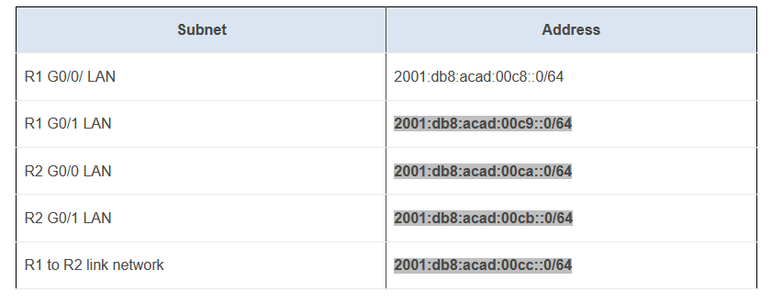

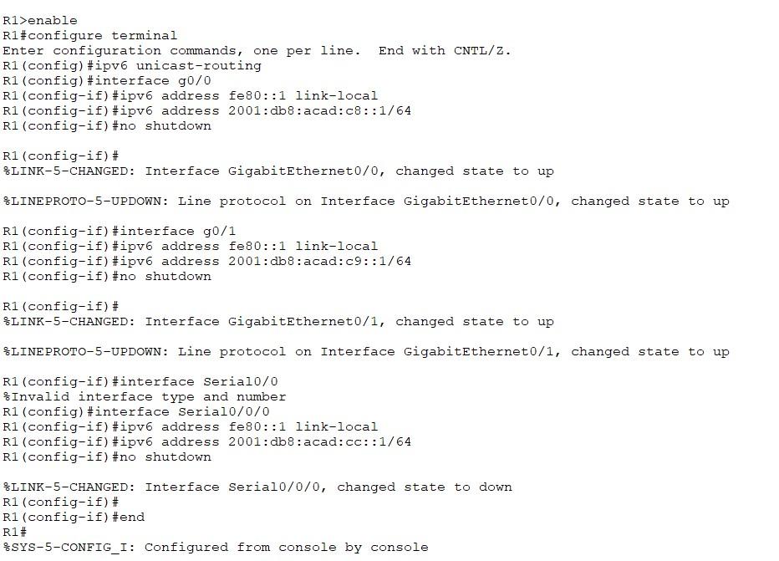

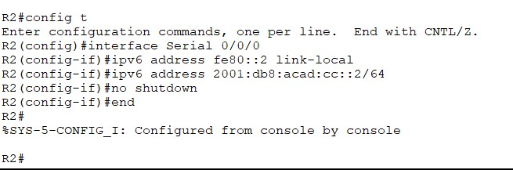

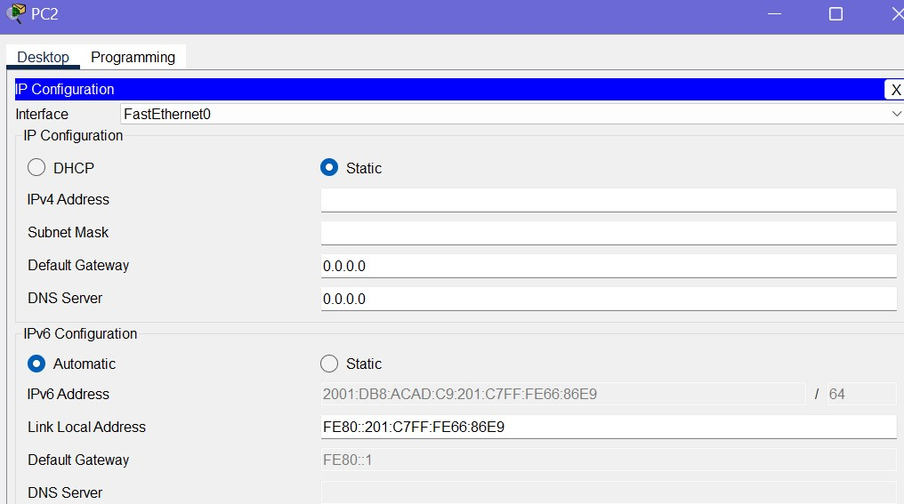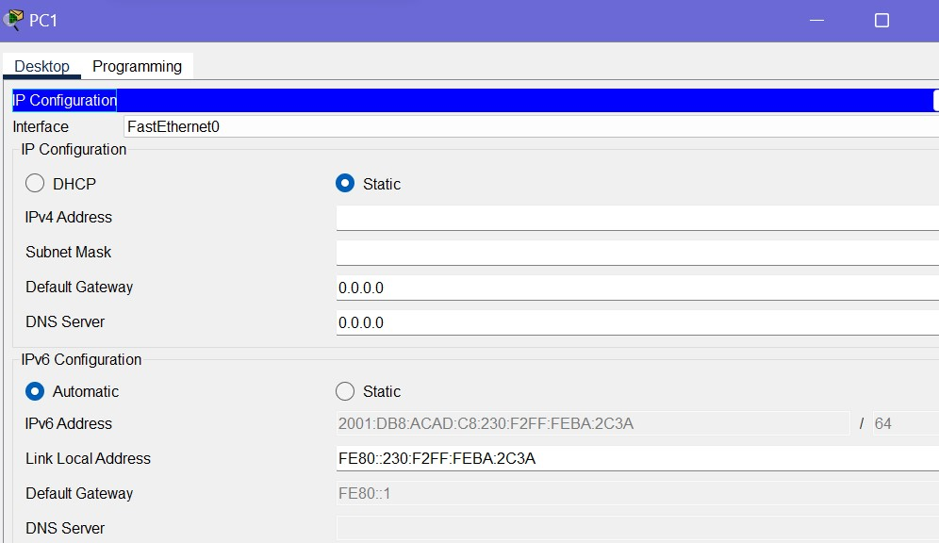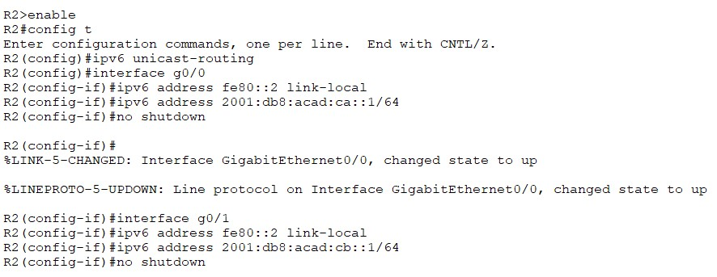

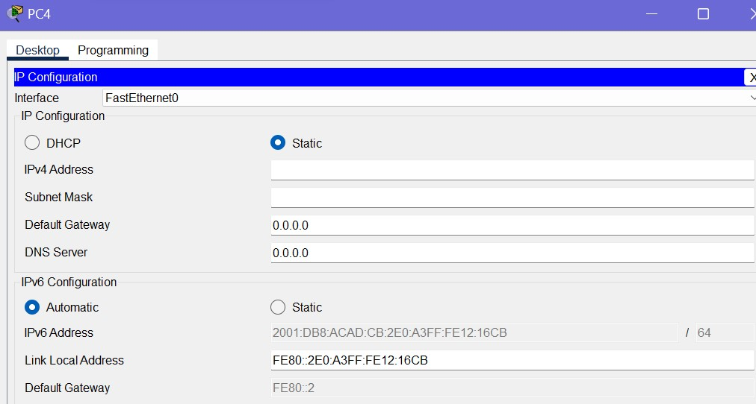

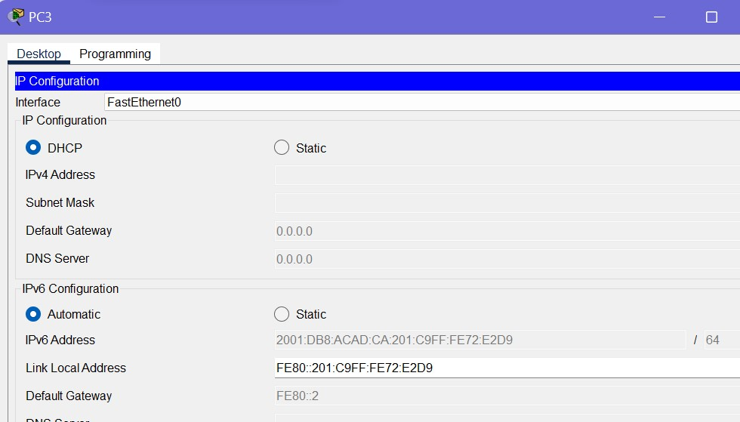

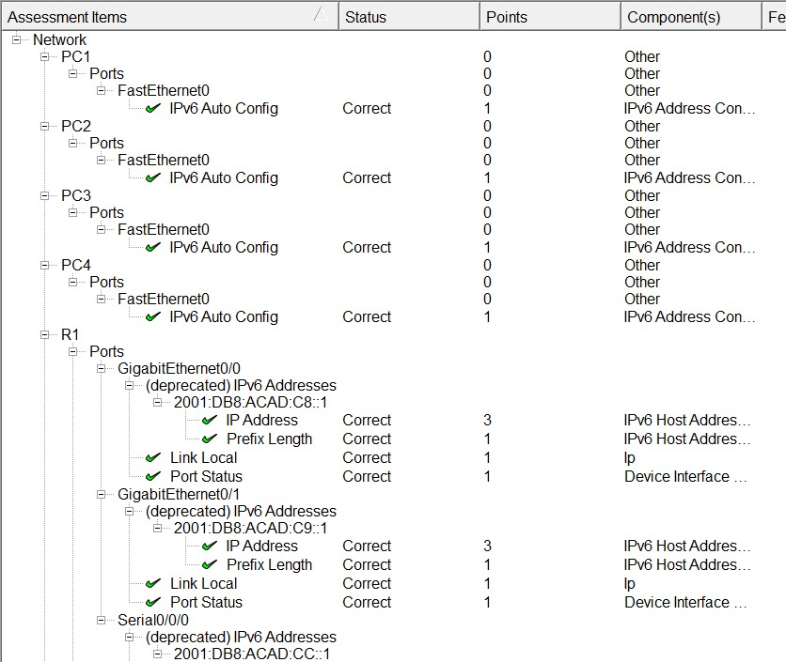

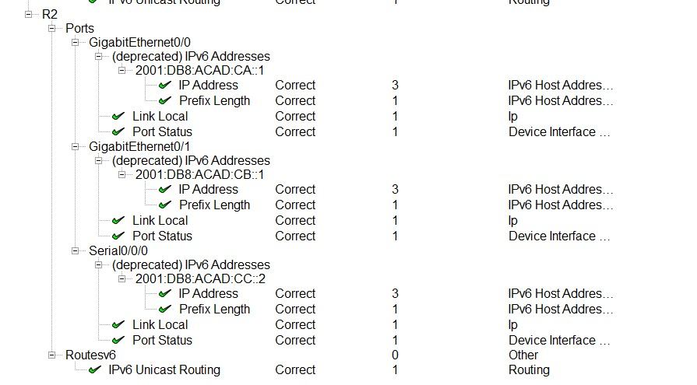

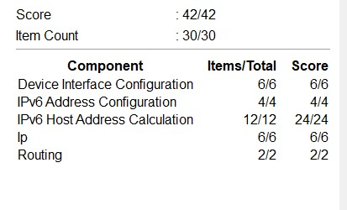

**Evaluation Table: -**

|  |  |  |  |
| --- | --- | --- | --- |
| **Criteria** | **Total Marks** | **Marks Obtained** | **Comments** |
| Concept (A) | 2 |  |  |
| Implementation (B) | 2 |  |  |
| Performance (C) | 2 |  |  |
| Total | 6 (To be scaled down to 1) | | |